Table of standard integrals
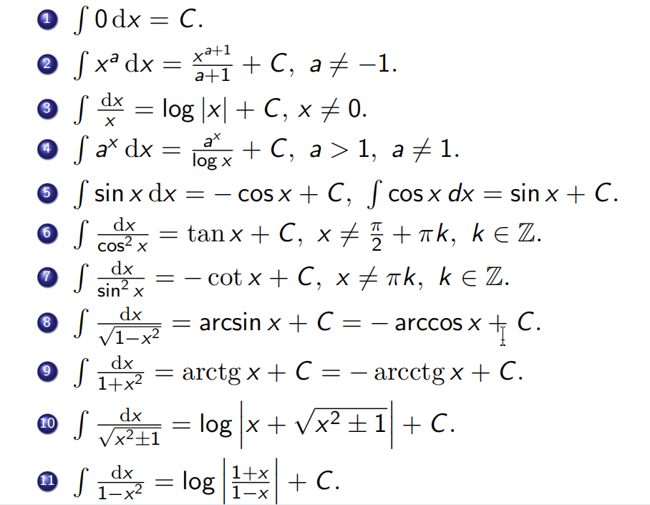
Example of primitives of an elementary function not be an elementary function.
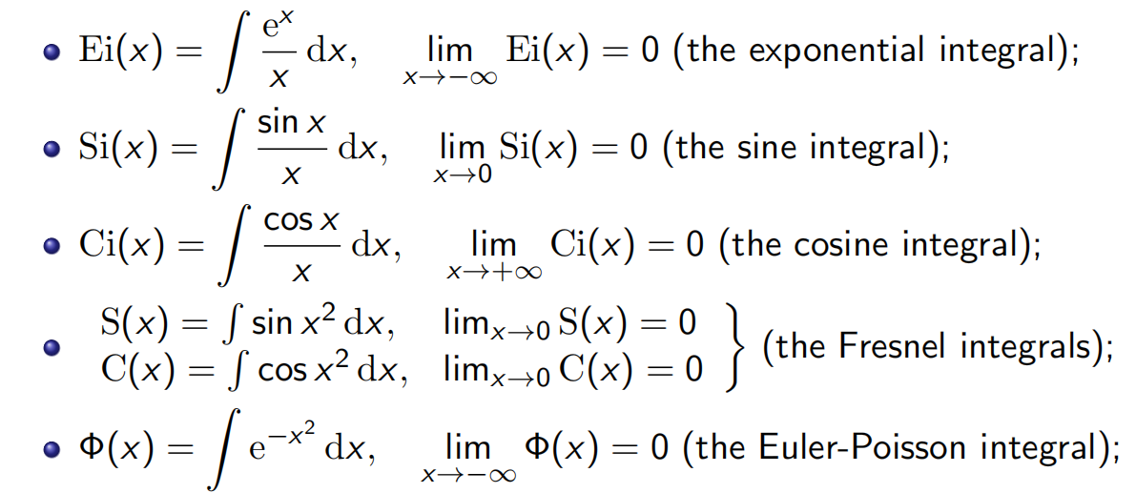

Forms of integrals which have some special submission to solve
